As of my last knowledge update in January 2022, smart bands, also known as fitness trackers or wearables, have been a popular technology for monitoring various aspects of health and fitness. They typically come equipped with sensors to track physical activity, heart rate, sleep patterns, and more. Since technology evolves rapidly, it's recommended to check the latest research and developments for the most up-to-date information. Here are some key areas of research related to smart bands:

1. **Health Monitoring:**
   * **Heart Rate Monitoring:** Research often focuses on the accuracy of heart rate measurements during various activities and under different conditions.
   * **Sleep Tracking:** Studies may investigate the reliability of sleep data and its relevance to overall health.
2. **Physical Activity and Exercise:**
   * **Activity Recognition:** Researchers explore the effectiveness of algorithms in recognizing and categorizing different physical activities.
   * **Caloric Expenditure:** Studies may assess the accuracy of estimating calorie expenditure during different types of exercises.
3. **Medical Applications:**
   * **Health Conditions Monitoring:** Some research may explore the potential of using smart bands for monitoring chronic conditions such as diabetes or hypertension.
   * **Fall Detection:** Studies might investigate the feasibility of using smart bands for fall detection, especially in elderly populations.
4. **User Experience and Behavior:**
   * **User Engagement:** Researchers may explore factors influencing user engagement and adherence to using smart bands over time.
   * **Behavioral Change:** Studies might examine the impact of smart band use on individuals' health-related behaviors.
5. **Technological Advancements:**
   * **Sensor Accuracy:** Research may focus on improving the accuracy of sensors used in smart bands.
   * **Battery Life:** Efforts are made to enhance the battery life of smart bands to improve user experience.
6. **Privacy and Data Security:**
   * **Data Protection:** Research investigates methods to ensure the security and privacy of user data collected by smart bands.
   * **Ethical Considerations:** Studies may explore the ethical implications of collecting and using health-related data from wearables.
7. **Integration with Healthcare Systems:**
   * **Healthcare Partnerships:** Research might explore collaborations between wearable technology companies and healthcare providers to integrate data into patient care.

**The Origins of Fitness Trackers**

Horologist and inventor Abraham-Louis Perrelet is credited with creating the first, albeit rudimentary, pedometer, while it’s also been suggested that American Founding Father Thomas Jefferson later produced his own mechanical pedometer, improving on Perrelet’s original design.

Fitness trackers, as we know them today, first surfaced in 1965 with the Manpo-kei, which translates to ‘10,000 steps meter’ and was invented by Dr Yoshiro Hatano. Dr Hatano, a Japanese professor at the Kyushu University of Health and Welfare, was researching at the time how to combat obesity.

He posited that 10,000 steps provided the proper balance of caloric intake and activity-based calorie expenditure to maintain a healthy body. Modern fitness trackers to this day still use 10,000 steps as a benchmark goal; however, a recent study published in the International Journal of Obesity suggests that 15,000 steps may actually be a more beneficial target to aim for.

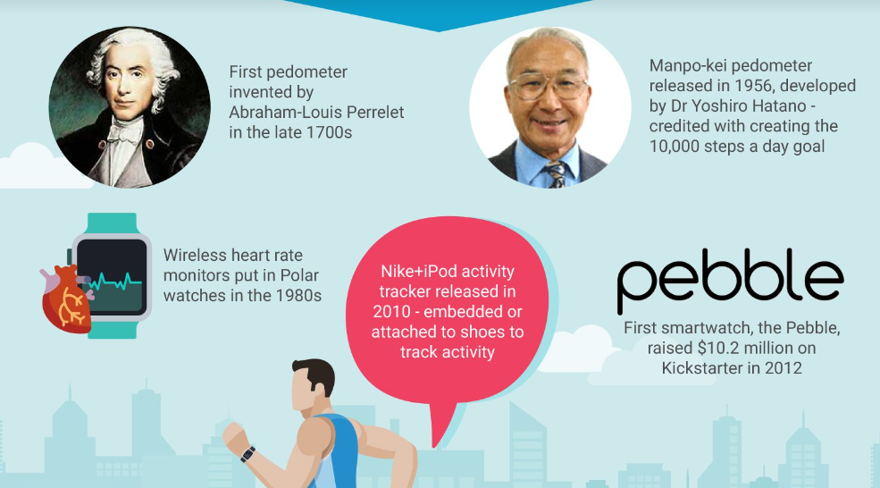

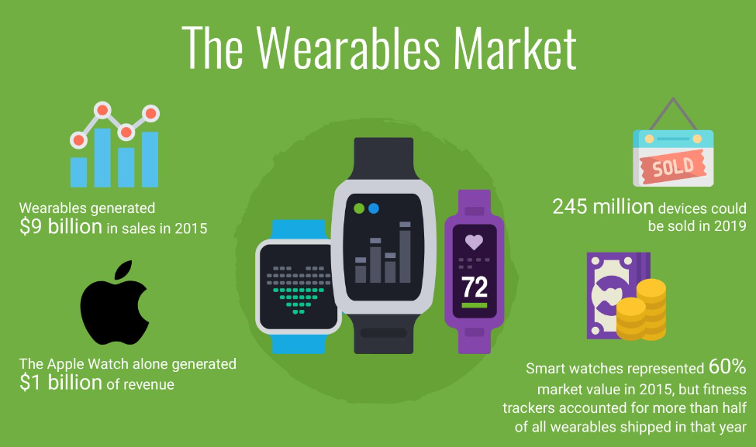

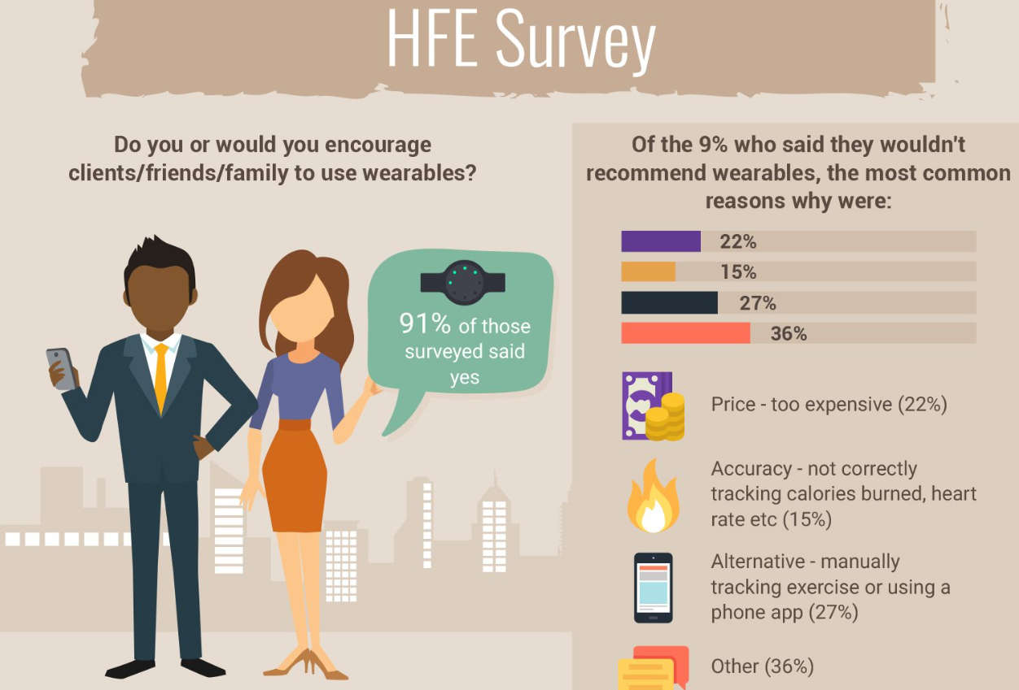

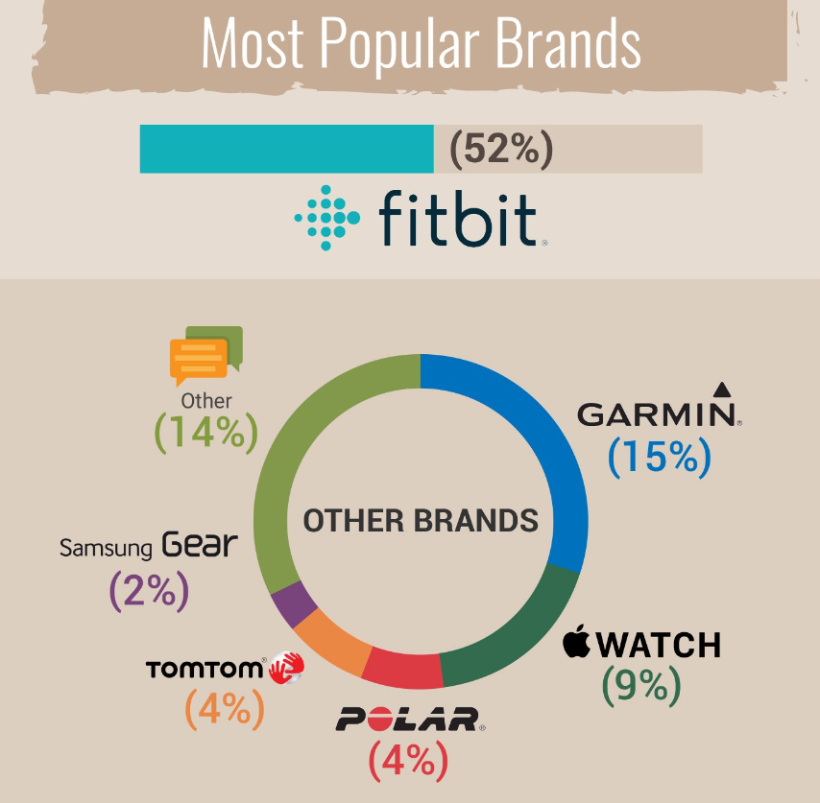 

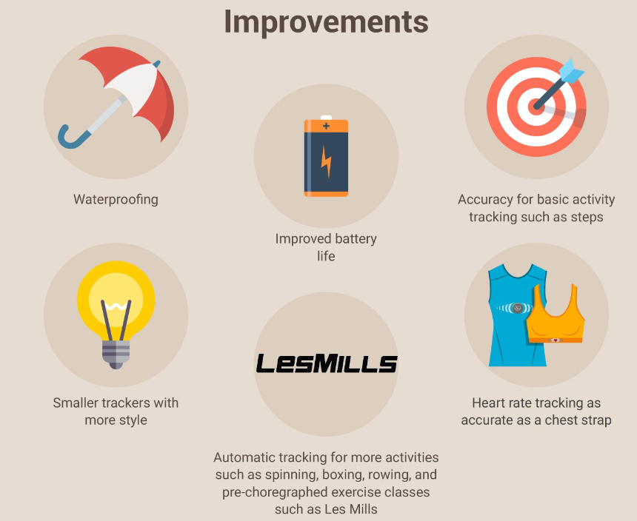 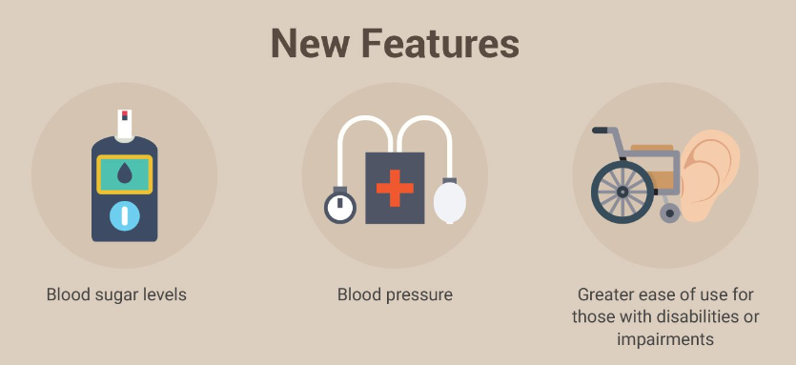

**Key points:**

* **300** fitness professionals surveyed.
* **91%** would encourage clients, friends and family to use wearables
* Price, lack of accuracy and using alternate devices were the most common reasons why wearables were not recommended
* The most popular wearables brand was Fitbit with 52%
* Better waterproofing, improved battery life and increased accuracy were some of the most requested features for improvement
* Those surveyed would also like to see blood sugar level readings, blood pressure readings and great ease of use for those with disabilities included in future iterations of wearables

Fitness bands, also known as activity trackers or smart bands, are wearable devices designed to monitor and track various aspects of an individual's health and fitness. The features of fitness bands can vary among different models and brands, but here are some commonly used features:

Step Tracking: Counts the number of steps taken throughout the day, providing an estimate of your physical activity.

Distance Tracking: Measures the distance traveled, often using accelerometers or GPS.

Calorie Burn Tracking: Estimates the number of calories burned based on factors like activity level, age, weight, and gender.

Heart Rate Monitoring: Measures your heart rate continuously or periodically, providing insights into your cardiovascular health and workout intensity.

Sleep Tracking: Monitors your sleep patterns, including duration, quality, and different sleep stages. Some devices provide insights and tips for improving sleep.

Activity Recognition: Automatically recognizes and categorizes different types of activities, such as walking, running, cycling, and more.

Water Resistance: Many fitness bands are water-resistant or waterproof, allowing you to wear them while swimming or during other water-based activities.

Smartphone Notifications: Receives and displays notifications from your smartphone, such as calls, messages, and app alerts.

GPS Tracking: Uses GPS technology to track outdoor activities with more accuracy, providing route maps and distance measurements.

Exercise Modes: Offers specific modes for various exercises, like running, cycling, weightlifting, yoga, and more, providing tailored data for each activity.

Compatibility: Syncs with a companion app on your smartphone or tablet, allowing you to view detailed statistics, set goals, and track progress over time.

Long Battery Life: Designed for extended use without frequent charging, typically lasting several days to weeks on a single charge.

Customizable Watch Faces: Allows users to personalize the appearance of the fitness band with different watch faces. Interchangeable Bands: Some fitness bands have interchangeable bands, allowing users to switch out the band for a different color or style.

Social Features: Enables users to connect with friends or join communities within the associated app for challenges, competitions, and social motivation.

Health Metrics: In addition to heart rate, some fitness bands may track other health metrics like blood oxygen saturation (SpO2), stress levels, and menstrual cycles.

Music Control: Allows users to control music playback on their smartphones directly from the fitness band.

***How do fitness trackers measure your heart rate?***

Have you ever wondered how smartwatches and wrist-based fitness trackers can tell what your heart rate is? I’ve been wearing an Apple Watch for a few months now, and it’s fun to see what my heart rate is during and after workouts. But it got me thinking about how this technology works, and whether it’s accurate.

Apple Watch

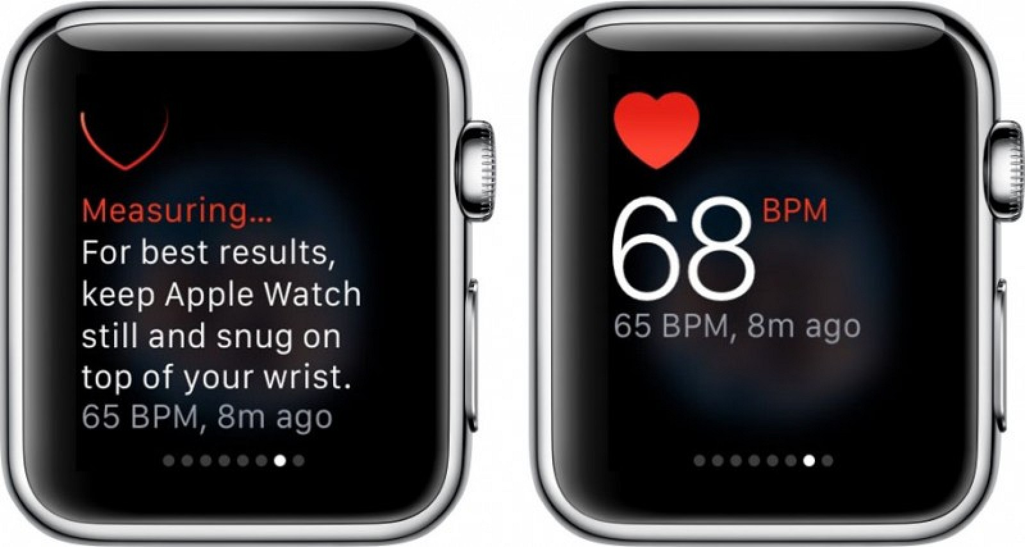

According to Apple, the Watch uses a technology called [photoplethysmography](https://en.wikipedia.org/wiki/Photoplethysmogram), or PPG, to measure heart rate. It’s essentially testing how much red or green light it can see when looking at the skin on your wrist. Blood is red because it reflects red light and absorbs green light, so when your heart beats, there’s more blood flow in your wrist, and more green light absorption. Between heart beats, there’s less absorption of green light.

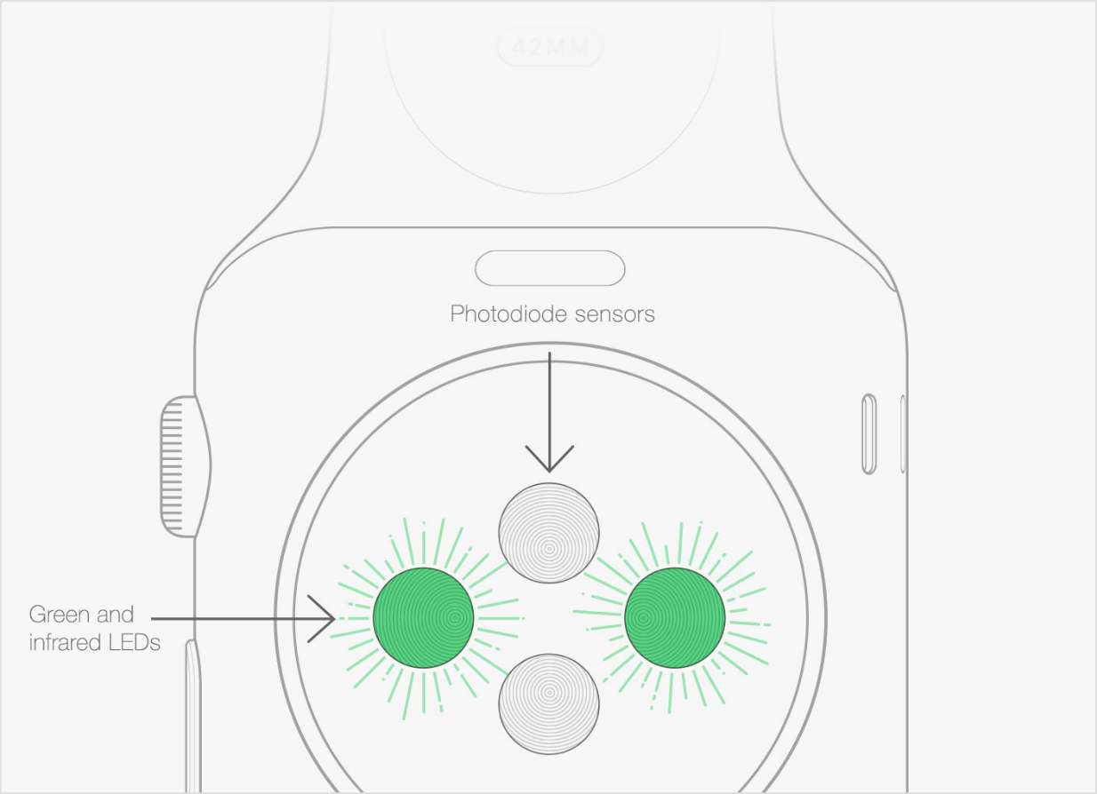

*By flashing its LED lights hundreds of times per second, Apple Watch can calculate the number of times the heart beats each minute — your heart rate.*

You might have even seen this in apps on your phone before. [Using your phone’s camera](http://ieeexplore.ieee.org/xpl/login.jsp?tp=&arnumber=6072801&url=http%3A%2F%2Fieeexplore.ieee.org%2Fxpls%2Fabs_all.jsp%3Farnumber%3D6072801), the same technology can be applied on-demand. In fact, this technology is quite old—apparently it was [first used in the late 1800s](http://www.valencell.com/blog/2015/10/optical-heart-rate-monitoring-what-you-need-know). At that time, people would “hold their hand up to a candle in a dark room to see the vascular structure and blood flow”.

This technology is also [used in hospitals](http://www.valencell.com/blog/2015/10/optical-heart-rate-monitoring-what-you-need-know)—if you’ve ever seen a finger or ear clip that measures pulse and blood oxygen levels, it’s using PPG.

The Apple Watch has two heart rate monitoring modes: when you put the watch into workout mode, it will track your heart rate continuously. The rest of the time, the heart rate sensor uses infrared light to measure your heart rate every 10 minutes (unless your arm is moving, which makes it hard to get a reliable reading). You can also check your heart rate anytime from the heart rate glance.

Because the watch relies on testing the light absorption of your skin to infer your heart rate, there are lots of ways the watch can struggle to get an accurate reading—or any reading at all. Tattoos, for instance, can block the heart rate sensor’s light. Moving your arm around can make it hard to get an accurate reading—Apple says you’ll get more accurate readings from rhythmic movements, such as running or cycling, that you would from a sport like tennis or boxing, where you’re making inconsistent movements. It can also be hard to get an accurate reading when you’re exercising in cold weather.

There’s obviously a debate about how accurate this technology is even in the perfect circumstances. [Users have complained about inaccurate readings](http://www.techtimes.com/articles/99152/20151024/apple-watch-problems-owners-complain-apple-watch-heart-rate-readings-completely-off-the-mark.htm) during workouts that involve lots of irregular movements, which is something Apple points out as causing trouble for the watch’s sensors. How the sensors are worn can also affect the output: wearing the watch too loosely [can give inaccurate readings](http://www.tomsguide.com/us/heart-rate-monitor,review-2885.html).

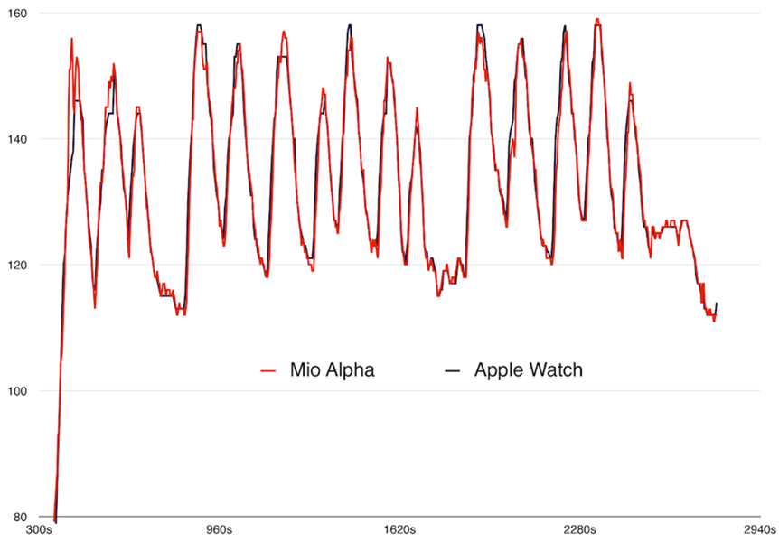

[Other tests](http://9to5mac.com/2015/05/08/apple-watch-heart-rate-monitor-accuracy/) have shown the heart rate readings to be very accurate (see graph above), but without a study with a large sample size, we can’t make a call on how accurate the tech is on average.

Fitbit

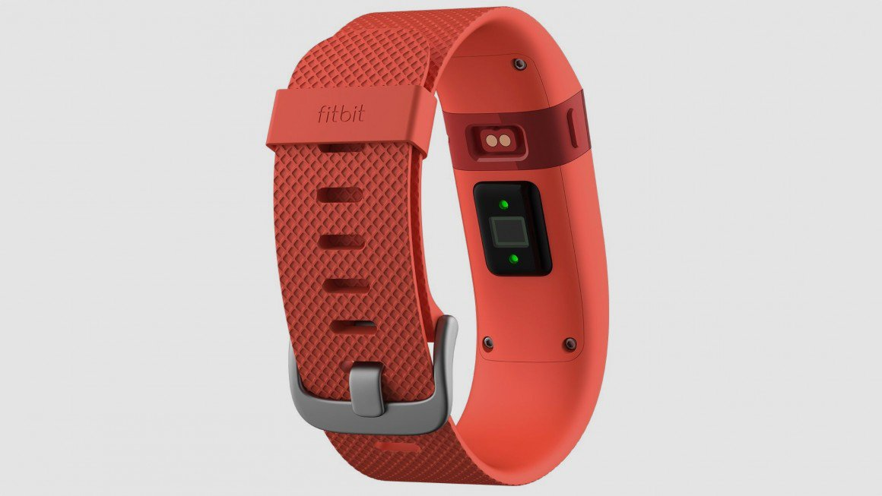

Fitbit doesn’t mention photoplethysmography, but [their tech](https://help.fitbit.com/articles/en_US/Help_article/Heart-rate-FAQs) seems to be inline with Apple’s. The Fitbit bands with heart rate tracking built-in (the Charge HR, Surge, and Blaze) uses “optical heart rate sensors that still maintain extended battery life”.

Fitbit brands their heart rate tech as PurePulse—calling it “the only heart rate technology to offer automatic, continuous wrist based tracking for all-day health insights and workout intensity”. The Fitbit trackers have the same struggles as the Apple Watch: you need to wear the band correctly, and tight enough for the lights to be touching your skin, and irregular exercise like boxing can throw off the measurements. Fitbit [also suggests](https://help.fitbit.com/articles/en_US/Help_article/Heart-rate-FAQs) wearing their trackers higher on your wrist to get more reliable readings.

***How does my Fitbit device measure my SpO2 level?***

Your Fitbit device measures your SpO2 levels while you sleep using red and infrared sensors on the back of the device. The sensors shine red and infrared light onto your skin and blood vessels, and use the reflected light that bounces back to estimate how much oxygen is in your blood:

* Richly oxygenated blood reflects more red light than infrared light.
* Poorly oxygenated blood reflects more infrared light than red light.

***what does gyroscope do in a fitness band?***

A gyroscope is a sensor in a fitness band that measures angular velocity. It helps detect changes in movement and orientation and can accurately track physical movements.

**Here are some other uses for a gyroscope in a fitness band:**

* Map applications: Gyroscopes can help guide map applications.
* Screen rotation and step counting: Gyroscopes can track the orientation of a smartwatch, enabling features like screen rotation and step counting.
* 3D workout motions: A 3-axis gyroscope can be paired with a 3-axis accelerometer to provide a "6 degree of freedom" motion tracking system. This combination can help fitness trackers better track 3D workout motions.
* Altitude measurement: Gyroscopes can be used for altitude measurement for mountain climbing.

***Accelerometer:***

An accelerometer sensor takes inertial measurements of velocity and position. Usually on three axes, it can sense inclination, tilt, and orientation of the body as well. Naturally this is very important for any fitness tracker as most steps taken by the individual will be actually recorded by this sensor.